1.5 Project: Inheritance, Composition, and User Interactions

Jessie Marie Sosniak

ECPI University

SDC330L: Object Oriented Programming using Java Lab

Mr. Randy Bellet

November 13, 2025
For my term project, I will be implementing a Rolodex/Contacts Application using Java. The application will be console-based and designed to allow users to manage a categorized contact list with full CRUD functionality. Contact types will include Business, Family, Friend, School, and Other. The user experience will be simple, intuitive, and entirely text-driven through the console.
When the application starts, the user will see a title line printed to the console, followed by a blank line and then a set of brief, clear instructions. This introduction will orient the user to the available commands and how to interact with the system. The instructions will explain that users can type a number to select an action, type “X” to exit the application from the main menu, and type “R” to return to the previous menu from any submenu. Input will not be case sensitive, so both uppercase and lowercase letters will be accepted for these commands.
The main menu will present the user with five options: Add a Contact, Remove a Contact, Update a Contact, Display Contacts, and Exit Application. Each option will be numbered, and the user will select an action by typing the corresponding number. The exit option will always be available from the main menu and will be listed last. Submenus, such as those under Display Contacts, will follow a similar structure and include a “Return to Main Menu” option, which the user can activate by typing “R”.
To prevent accidental termination of the program, selecting the exit option will trigger a confirmation prompt. The user will be asked, “Are you sure you want to exit the program? (Y/N)” and must respond accordingly. Input for this prompt will also not be case sensitive. A response of “Y” or “y” will confirm and terminate the program, while “N” or “n” will cancel the exit and return the user to the main menu. Any other input will trigger a re-prompt until a valid response is received.
Contact information will be displayed in a clean, readable block format rather than a tabular layout. This decision was made to avoid formatting issues and ensure clarity. Each contact will be presented with labeled fields, including Name (a combination of first name and last name), Phone, Email, Address (a combination of street address, city, state, and zip code), and Relation. The relation field will be selected by the user from a menu offering Work, School, Family, Friend, or Other. Each contact block will be separated by a blank line to enhance readability.
This document outlines the intended user experience and interaction flow for the Contacts Application. It serves as a foundation for the development process and will guide the implementation of the Week 1 code and future enhancements throughout the term.
The application had to be compiled via Command Prompt as VSCode was having trouble executing the program. I will troubleshoot this later, but for now, here is the program running without issue from Command Prompt (other screenshots and GitHub link are on next pages):
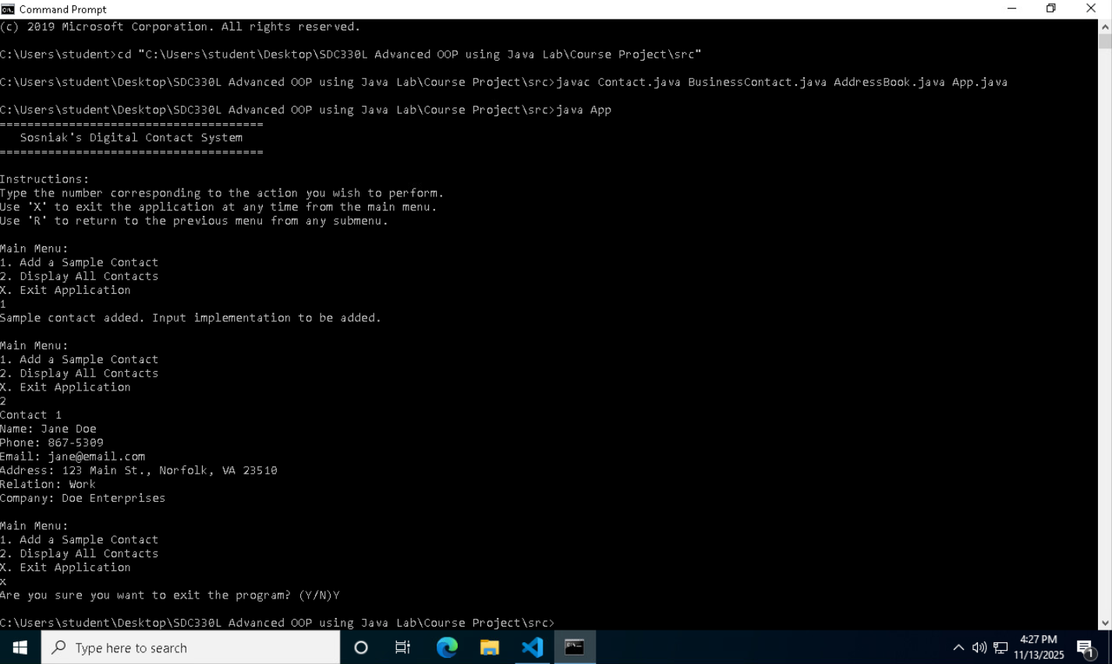
Screenshot Showing Inheritance: 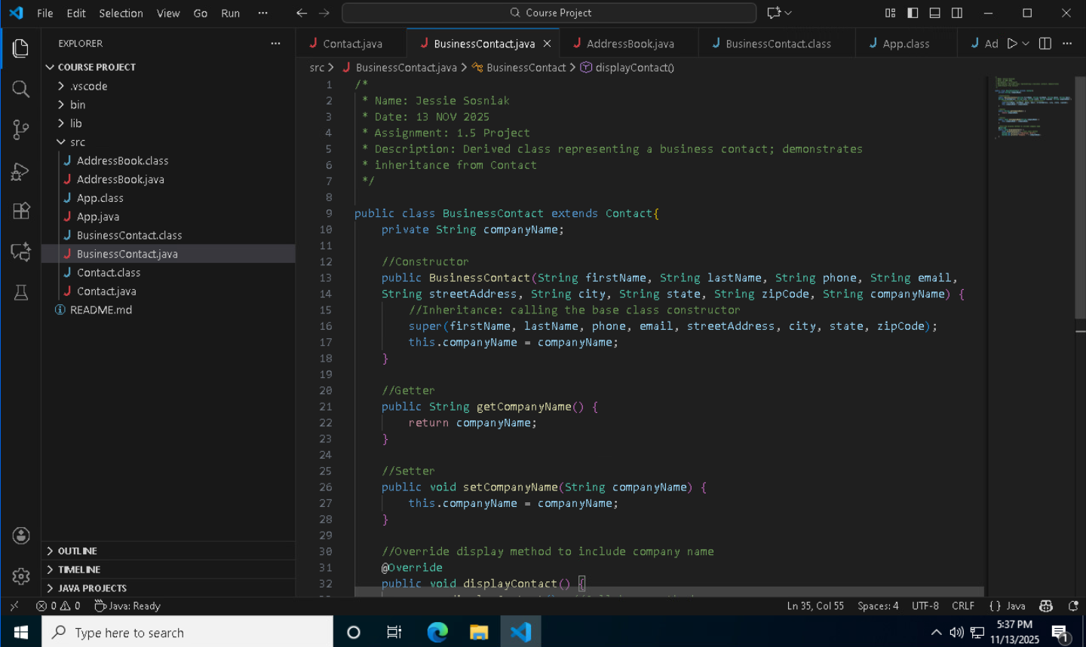
Screenshot Showing Composition: 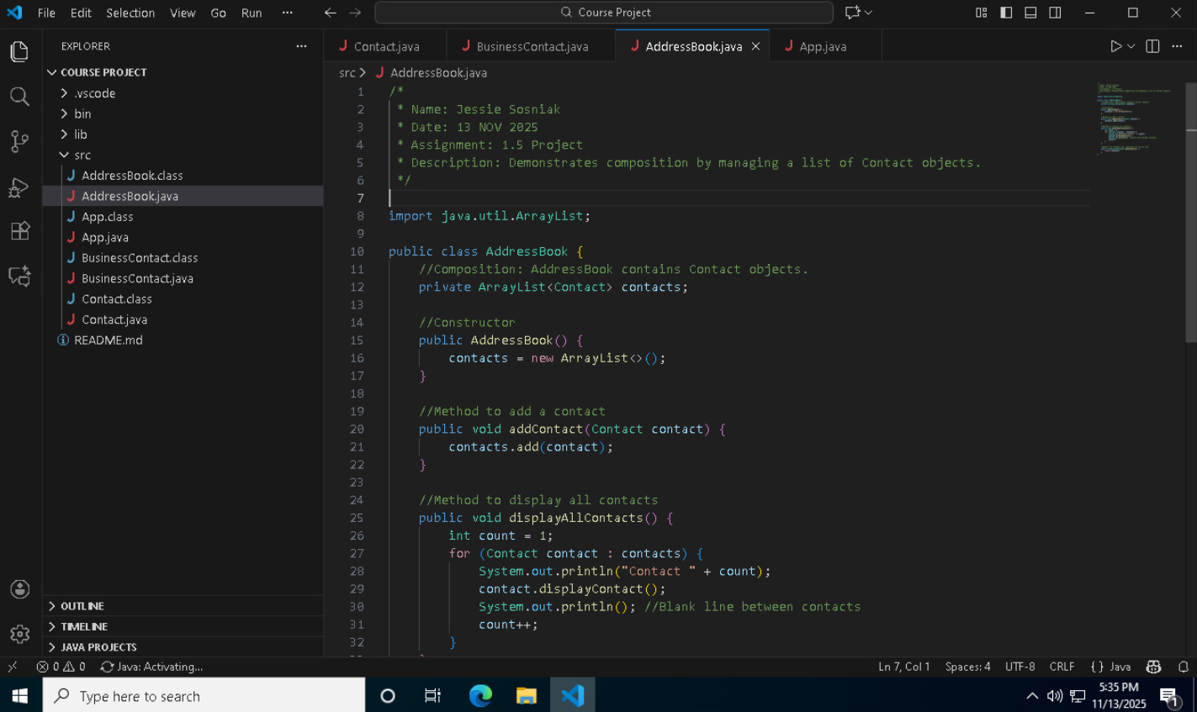
GITHUB LINK: https://github.com/Ecoz03/SDC330L-Advanced-Object-Oriented-Programming-Using-Java-Lab.git
Resources

